**KANNADA MNIST**

Kannada is a language spoken predominantly by people of Karnataka in southwestern India. The language has roughly 45 million native speakers and is written using the Kannada script.

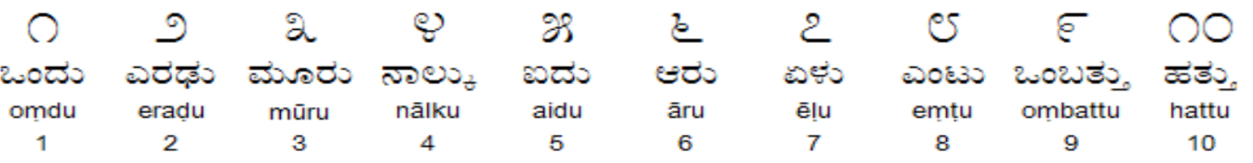

**Data Description**

The data files train.csv and test.csv contain gray-scale images of hand-drawn digits, from zero through nine, in the Kannada script. Each image is 28 pixels in height and 28 pixels in width, for a total of 784 pixels in total. This pixel-value is an integer between 0 and 255, inclusive.

The training data set, train.csv, has 785 columns. The first column, called label, is the digit that was drawn by the user. The rest of the columns contain the pixel-values of the associated image.

Each pixel column in the training set has a name like pixel{x}, where x is an integer between 0 and 783, inclusive. To locate this pixel on the image, suppose that we have decomposed x as x = i * 28 + j, where i and j are integers between 0 and 27, inclusive. Then pixel{x} is located on row i and column j of a 28 x 28 matrix, (indexing by zero).

For example, pixel31 indicates the pixel that is in the fourth column from the left, and the second row from the top, as in the ascii-diagram below.

Visually, if we omit the "pixel" prefix, the pixels make up the image like this:

000 001 002 003 ... 026 027

028 029 030 031 ... 054 055

056 057 058 059 ... 082 083

| | | | ... | |

728 729 730 731 ... 754 755

756 757 758 759 ... 782 783

The test data set, test.csv, is the same as the training set, except that it does not contain the label column.

**Files**

* train.csv - the training set
* test.csv - the test set
* Dig-MNIST.csv - an additional labeled set of characters that can be used to validate or test model results